Design Planning

## Structure Diagrams

* Entity-Relationship Diagram - a visual representation that shows how different entities relate to each other within a system, often a database or a business process.

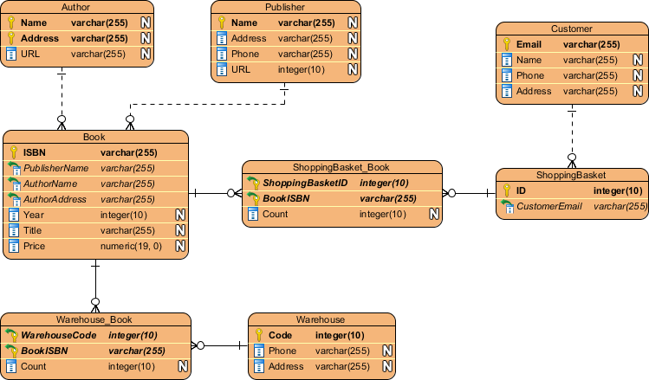

## Project Management Diagrams

* Work Breakdown Structure Diagram (WBS) - a hierarchical decomposition of a project into smaller, more manageable components or tasks. It's a visual representation that breaks down the entire project scope into a clear, organized structure, making it easier for project teams to plan, schedule, and track progress.

